**INTRODUCTION**

A simple Rain Detection System can be easily built by interfacing an Arduino with Rain Sensor. The sensor will detect any rainfall falling on it and the Arduino board will sense it and can perform required actions. A system like this can be used in many different fields, such as agriculture and automobile fields. Rainfall detection can be used to automatically regulate the Irrigation process. Also, continuous rainfall data can help farmers use this smart system to automatically water the crop only when absolutely required. Similarly, in the automobiles sector windshield wipers can be made fully automatic by using the rain detection system. And the Home Automation Systems can also use rain detection to automatically close windows and adjust room temperature. In this tutorial, we will build a basic rain sensor using Arduino with a buzzer. You can then use this set-up to build anything you wish on top of it. Also, note that the rain sensor module is also referred to as a raindrop sensor or rain gauge sensor or rainwater sensor based on usage, but they all refer to the same sensor used in this project and they all work on the same principle.

### ****MATERIALS REQUIRED****

The components used for this project are:

* Arduino UNO
* Rain sensor
* Buzzer
* Breadboard
* Connecting wires

**ARDUINO UNO**

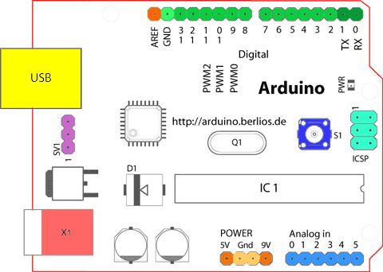

Arduino is an open-source electronics platform based on easy-to-use hardware and software. Arduino boards are able to read inputs - light on a sensor, a finger on a button, or a Twitter message - and turn it into an output - activating a motor, turning on an LED, publishing something online

.**RAIN SENSOR**

A rain sensor or rain switch is a switching device activated by rainfall. There are two main applications for rain sensors. The first is a water conservation device connected to an automatic irrigation system that causes the system to shut down in the event of rainfall.

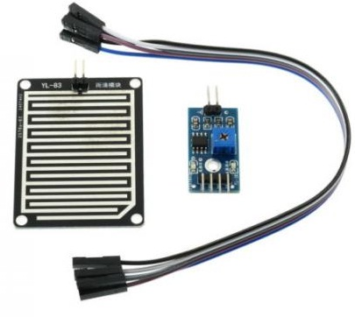

**BUZZER**

A buzzer or beeper is an audio signaling device, which may be mechanical, electromechanical, or piezoelectric (piezo for short). Typical uses of buzzers and beepers include alarm devices, timers, train and confirmation of user input such as a mouse click or keystroke.

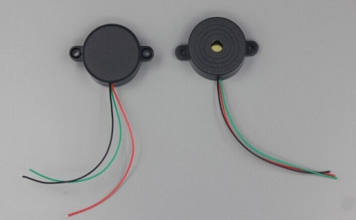

**figure: Buzzer**

**BREADBOARD**

A breadboard (sometimes called a plugblock) is used for building temporary circuits. It is useful to designers because it allows components to be removed and replaced easily. It is useful to the person who wants to build a circuit to demonstrate its action, then to reuse the components in another circuit.

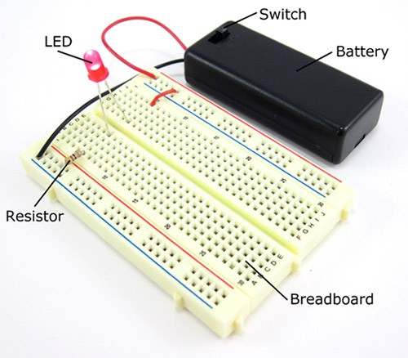

Figure : BREADBOARD

**CONNECTING WIRES**

Connecting wires are one of the most important components in an electrical circuit because these are the components through which electricity flows from one electrical component to another. It is with the help of wire that electricity flows from cell to light bulb.

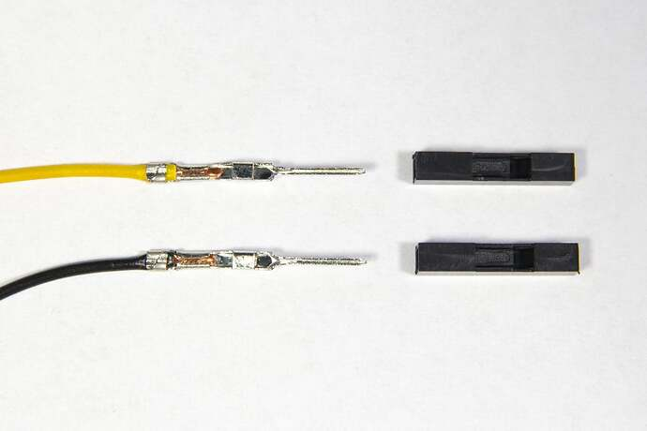

**Figure:CONNECTING WIRE**

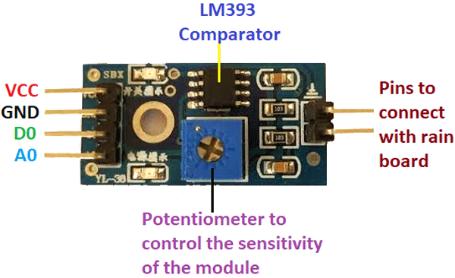

**The** **Rain control module** **:** which is shown below consists of 4 pins to connect the Arduino namely VCC, GND, D0, A0 and two more pins to connect the rain board module. In summary, the rain board module detects the rainwater, and the control board module is used to control the sensitivity and compare and convert the analog values to digital values.

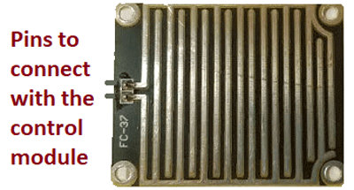

FIGURE**:**RAIN SENSOR

If the read sensor value is greater than the set value, then the program enters the loop, prints the message on serial monitor and switches on the buzzer

### ****CIRCUIT DIAGRAM****

The below circuit diagram shows you the circuit connections for the **Rain Drop Sensor with Arduino.** The design is done using proteus; the physical modules are similar to the modules which are shown in the circuit diagram.

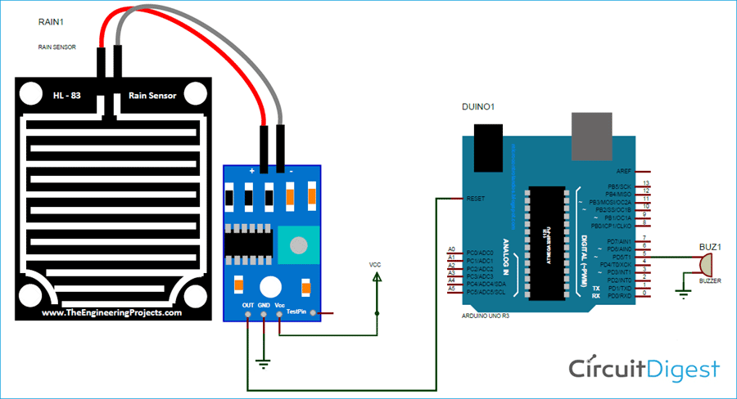

### ***CIRCUIT DIAGRAM***

### ****CODE EXPLANATION****

The **Arduino code for the rain sensor** was written using the Arduino IDE.

#define rainfall A0

#define buzzer 5

int value;

int set=10;

Defining pin A0 as rainfall, and pin 5 as a buzzer and declaring variable “value” and “set” as integers and setting its variable set value to 10. This value can be changed according to the required level of operation. If you want the buzzer to activate, even when there is little rain set it to a minimum value

void setup() {

Serial.begin(9600);

pinMode(buzzer,OUTPUT);

pinMode(rainfall,INPUT);

}

Initializing the serial communication, and setting the buzzer. Setting the rainfall pin as an output pin and input pin.

void loop() {

value = analogRead(rainfall);

Serial.println(value);

value = map(value,0,1023,225,0);

else{

digitalWrite(buzzer, LOW);

The program enters the else function only when the value is less than the set value. This function will switch off the buzzer when the set value is higher than the value of the sensor, which tells that there is no rain.

### ****WORKING OF RAIN SENSOR****

Working of the **rain sensor module** is simple to understand. During a sunny day, due to the dryness on the rain board module, it offers high resistance to the supply voltage. This voltage appears on the output pin of the rain board module as 5V. This 5V is read as 1023 if read by an analog pin of the Arduino.   During rain, the rainwater causes an increase in the wetness on the rain board, which in turn results in the decrease in the resistance offered for the supply. As the resistance decreases gradually, the output voltage starts to decrease.

When the rain board is fully wet, and the resistance offered by it is minimum, the output voltage will be as low as possible (approx. 0). This 0V is read as 0 value if read by an analog pin of the Arduino. If the rain board module is partially wet, the output of this rain board module will be with respect to the resistance it offers. If the resistance offered by the rain board module is in such a way that the output is 3V the read analog value will be 613. Formula to find ADC can be given by**, ADC = (analog voltage value X 1023)/5.** By using this formula you can convert analogvoltage to Arduino analog read value.

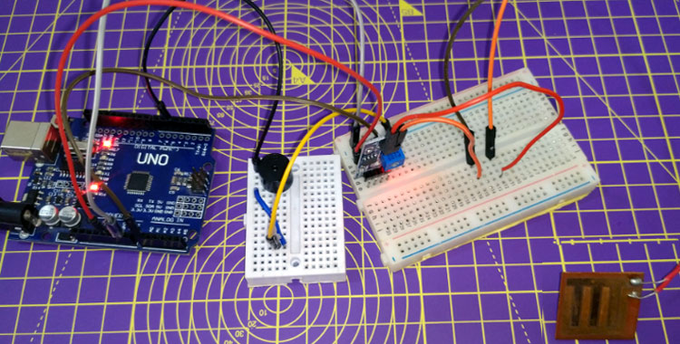

**RDUINO BASED RAINWORKING OF A DETECTION SYSTEM**

This system works in such a way that, when there is rain, the rainwater acts as a trigger, which switches on the buzzer. In the Rain Drop Sensor Arduino Code, we defined that pins 5, and A0 are buzzer and rainfall. By doing this, we can change the pins in the defined part of the function, and the remaining part of the code will be untouched. This will make the programmer in editing the pins easily.

**Code**

#define rainfall A0

#define buzzer 5

int value;

int set=10;

void setup() {

  Serial.begin(9600);

  pinMode(buzzer,OUTPUT);

  pinMode(rainfall,INPUT);

  }

void loop() {

 value = analogRead(rainfall);

 Serial.println("LOL");

 Serial.println(value);

 value = map(value,0,1023,225,0);

 Serial.println(value);

 if(value>=set){

  Serial.println("rain detected");

  digitalWrite(buzzer,HIGH);

 }

 else{

  digitalWrite(buzzer,LOW);

 }

 delay(200);

}

In the void loop, the *analogRead* command reads the value from the sensor. In the next line, the command *Serial.println(value),* prints the value on the serial monitor. This will be helpful while debugging. The map function maps the incoming value between 0 -225. The function format for the ***map*** is a map (value, min value, maximum value, value to be mapped for minimum value, value to be mapped for maximum value). The buzzer will be switched ON or OFF, depending on the set value and the output of the sensor. This value is compared in the if function, with the set value. If the value is greater than the set value, it will switch on the buzzer. If the value is less than the set value, the buzzer will be switched off.

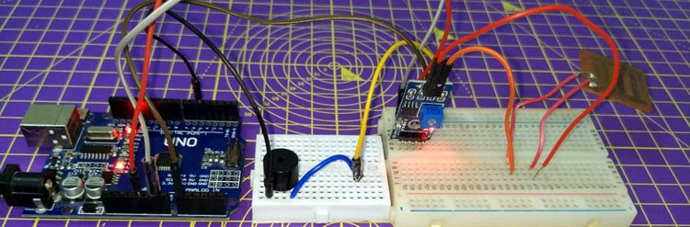

The complete working can be found in the video linked below. This is one application among the many, the same principle will be seen in windshield wipers, other home automation, agriculture sectors, etc. Hope you understood the project and enjoyed building something useful. If you have any questions, use the comment section below or use our forums for other technical questions.

**Working Video Link:**   
 <https://www.youtube.com/watch?v=jkAPzDJlxwk>

[] • 61K vie](https://www.youtube.com/watch?v=DNS1Jhx0MtU)